Initial Client Meeting

Initial approach:
- Introduce briefing and propose general ideas
  - Is our information in line with what you would expect from this project?

Client’s answer:
“It is, but I think you are going about this the wrong way. Instead of thinking about a concept for the game, focus on your strengths as a group and on what message you want to convey, and go from there.”

- We have determined that the target audience should be people from a younger demographic. Is this accurate to your expectations?

Client’s answer:
“There is no specific target demographic, you are allowed to choose your own target audience based on the game you are trying to make.”

- Has any sort of work been done on this project before? What about the second group working on this project (Group 7), are they making their own thing?

Client’s answer:
“This contest has been going on for a while, and Fontys decided to participate with their 2 teams to show that Dogfood Studios cares about sustainable development goals. There won’t be any friction between your group and the other group.”

Timeline:
- In the briefing we got it says the project is supposed to end on the 30th of March 2026, but our semester ends before then.
  - Can you explain exactly what this means for us as students?

Client’s answer:
“The project you were assigned is supposed to be part of a contest to create a game that shows certain sustainable development goals, such as combating climate change. It is up to you if you want to continue working on it after this semester is over.”

- We have determined that by the end of this semester we will have created a game in the Proof-of-Concept stage of development. Is this in line with your expectations for this semester?

Client’s answer:
“Yes, that is fine, as long as the main message is conveyed.”

Restrictions:
- Are there any sort of software restrictions? Must we use Gitlab instead of Github, for example? What about restrictions for the game itself, like genre or theme?

Client’s answer:
“In terms of the game itself, you have complete creative freedom, and the same can be said about the software. In terms of version control, you should ask your assessors.”

Proof of the meeting taking place
Emails between our group and the client:
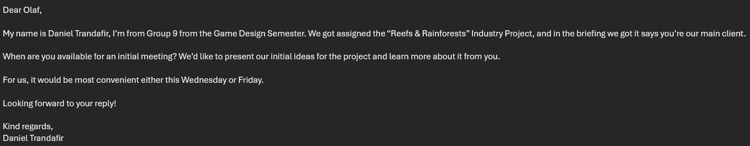
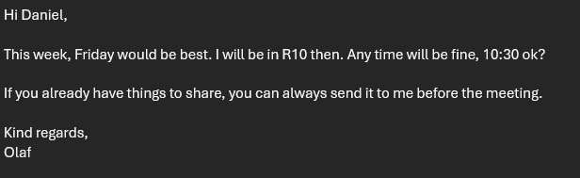
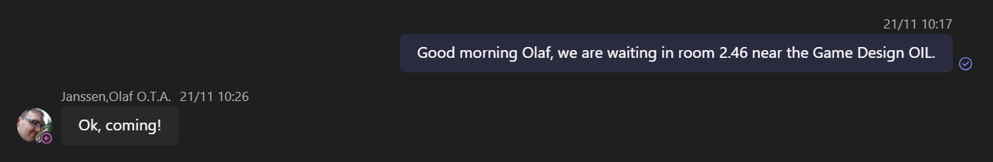

We have also established with the client that we will be holding meetings on Friday at 10:30 at the end of each sprint to discuss our progress.

